TCN4211
Telecommunication Networks

Lab Number 4
Title Static Routing Configuration

Author Name: Anaisy Garcia PID: 5734454

Oct 4.



Florida International University

OBJECTIVES:
The objective in this lab are build a topology containing multiple routers, understand how to set up static routing in Cisco Packet Tracer, learn basic syntax, and understand how to use ping, netstat, and tracer to diagnose network connectivity issues.
EQUIPMENT and COMPONENTS USED
For this lab the equipment used was:
- Laptop
- Cisco Packet Tracer Program
Within the Cisco Program, the components used were three routers, and two generic PCs connected with cross-over cables.

EXPERIMENTAL METHOD AND PROCEDURE
- Set up the topology using three routers, and two generic PCs all connected with cross-over cables.
- Rename routers to r0, r1, and r2 and PCs to PC0 and PC1.
- Assign static IP addresses to PC0 and PC1.
- To configure router r0, open up CLI tab and write:
  - “n”
  - “enable”
  - “config terminal”
  - “int fa0/0”
  - “ip address 1.0.0.1 255.0.0.0”
  - “no shut”
  - “exit”
  - “int fa0/1”
  - “ip address 2.0.0.1 255.0.0.0”
  - “no shut”
  - “exit”
  - “exit”
  - “config terminal”
  - “ip route 3.0.0.0 255.0.0.0 2.0.0.2”
  - “ip route 4.0.0.0 255.0.0.0 2.0.0.2”
- To configure router r1, open CLI tab and write:
  - “n”
  - “enable”
  - “config terminal”
  - “int fa0/0”
  - “ip address 2.0.0.2 255.0.0.0”
  - “no shut”
  - “exit”
  - “int fa0/1”
  - “ip address 3.0.0.1 255.0.0.0”
  - “no shut”
  - “exit”
  - “exit”
  - “config terminal”
  - “ip route 1.0.0.0 255.0.0.0 2.0.0.1”
  - “ip route 4.0.0.0 255.0.0.0 3.0.0.2”
- To configure router r2, open CLI tab and write:
  - “n”
  - “enable”
  - “config terminal”
  - “int fa0/1”
  - “ip address 3.0.0.2 255.0.0.0”
  - “no shut”
  - “exit”
  - “int fa0/0”
  - “ip address 4.0.0.1 255.0.0.0”
  - “no shut”
  - “exit”
  - “exit”
  - “config terminal”
  - “ip route 2.0.0.0 255.0.0.0 3.0.0.1”
  - “ip route 1.0.0.0 255.0.0.0 3.0.0.1”
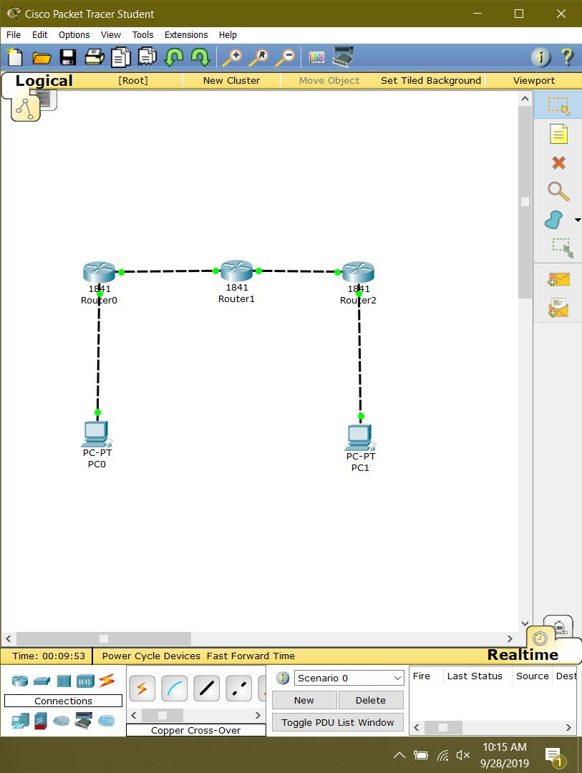
- Use “ipconfig” with in PC0 to check the IP address of the local host and the default gateway.
- Ping PC1 from PC0 to check connectivity with “ping 4.0.0.2”.
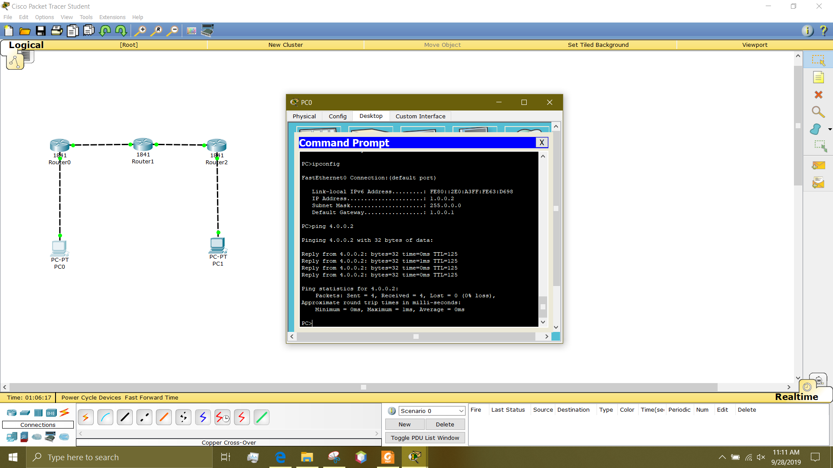
- Trace the route from PC0 to PC1 using “tracert 4.0.0.2”.
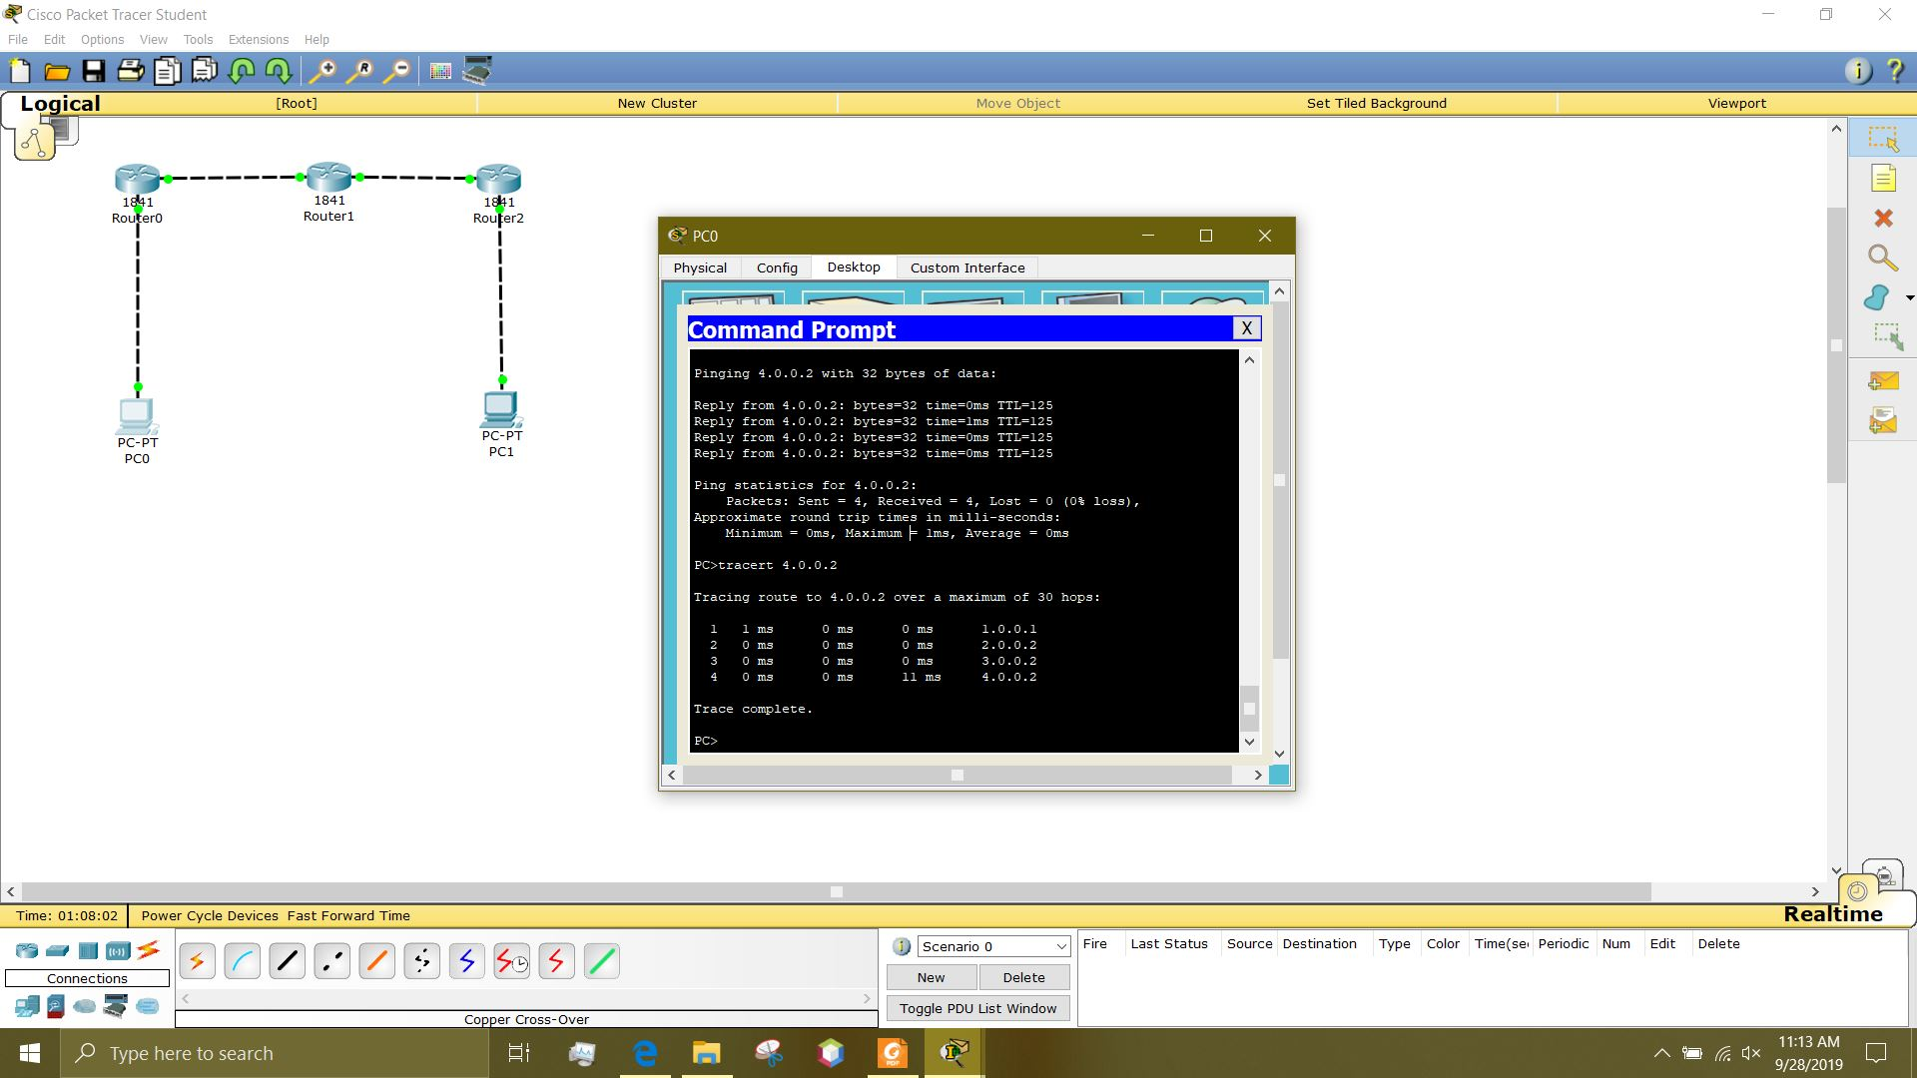
- Turn router 2 off, use ping to try to reach PC1, and use tracert to see the hops.
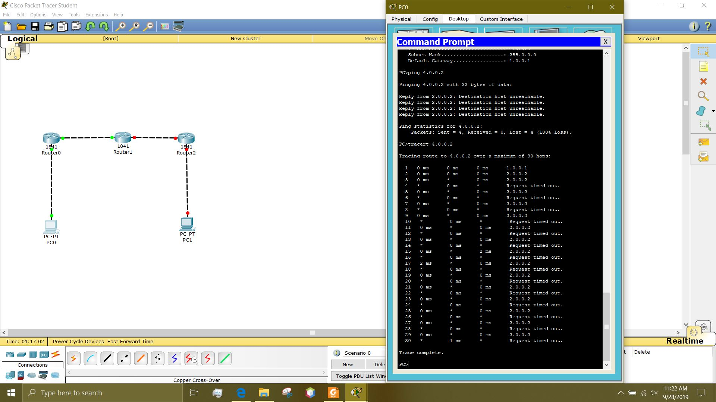
- In PC0s command prompt use “netstat -r” to see routing table.
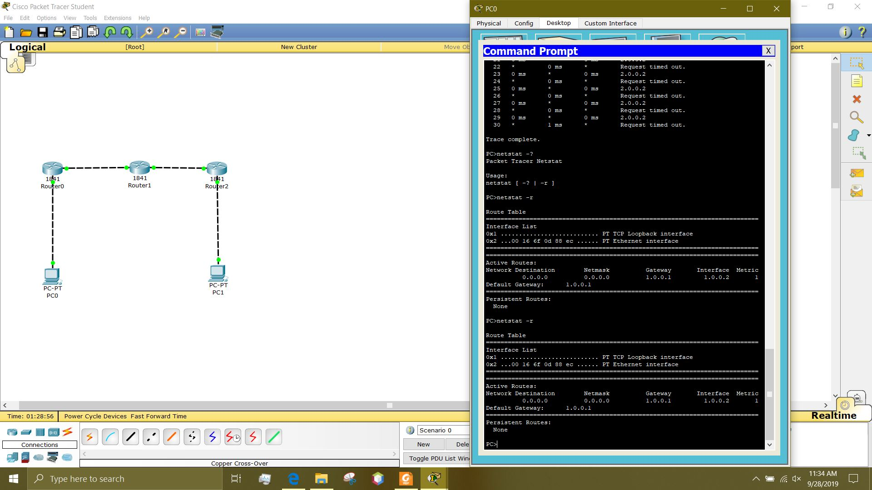
- Turn off router 0 and retry “netstat -r”.
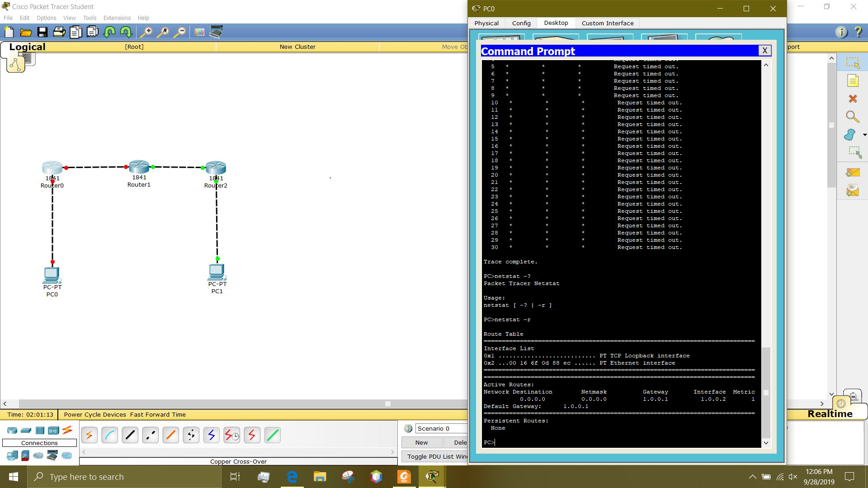

PROBLEMS/QUESTIONS
- How many hops from PC0 to PC1?
Four hops
What was the total time to reach the destination?
Eleven milliseconds
- Is PC1 reachable from PC0?
No, it is not.
Explain the tracert output.
It successfully hops three times but after those three, it cannot connect to the next router, therefore it repeats trying to make contact and timing out for 30 hops.
Can we use the tracert output to diagnose connectivity issue to PC1?
Yes, because it tells us when the request times out and at what IP address.
What is total number of hops used by tracert command?
Thirty hops.
- Explain the command output.
This is the routing table for PC0. This shows the default gateway and active routes to be taken.
Explain the command output.
This is the routing table for PC0. This shows the default gateway and active routes to be taken.

RECOMMENDATIONS and CONCLUSIONS
This lab consisted of understanding how to set up a network of routers and how to diagnose issues if they were to occur. Tracert allowed for testing healthy connections and if there is one that is not properly connected it allows for finding where this issue is occurring. Netstat showed the active TCP connections, listening ports, ethernet statistics, an ip routing table, and ipv6 statics.

